THE MARINE IMPACT OF UBC’S SINGLE-USE PLASTICS
A Collaboration Between UBC’s Ocean Leaders and Sustainability and Engineering in Campus and Community Planning as part of the SEEDS Sustainability Programs

Prepared by Carolina Sánchez

Table of Contents
Executive Summary 2
1 Introduction 4
2 Literature survey on single-use plastics 4
2.1 History, global production and entry into marine environments 4
2.2 Environmental impact 5
2.2.1 Encounter risk 5
2.2.2 Entanglement risk 7
2.2.3 Ingestion risk 7
2.2.4 Contamination risk 8
2.2.5 Other risks 9
2.2.6 Level of impact risk 10
2.3 Regulatory and other strategies to reduce single-use plastic pollution 10
2.3.3 Canadian context 12
2.3.4 Strategies implemented by other universities 12
3 UBC Single-use plastics data collection 13
3.1 Methods of data collection and extrapolation 13
3.1.1 Food businesses 13
3.1.2 The UBC Bookstore 15
3.1.3 Research labs 15
3.1.4 Information on recyclability 15
3.2 Results from data collection and extrapolation 16
3.2.1 Food businesses & the UBC Bookstore 16
3.2.2 Research labs 16
3.3 Recyclability of single-use plastic items consumed at UBC 18
4 Impact of single-use plastics on marine life 19
4.1 Framework 19
4.2 Risk assessment model 20
5 Discussion and recommendations 24
6 Next Steps 25
References 26
Appendix A 28
Appendix B 29
Appendix C 31

Executive Summary

Project Background
The potential impact of the University of British Columbia’s (UBC) single-use plastics on marine life has been identified as an area of concern that requires further characterization and quantification (Beaty and Davis, 2018). To develop a better understanding of the extent of this issue, this project aimed to investigate sector-specific single-use plastic consumption, and therefore support the development of effective policy and public engagement strategies to reduce the university’s contribution to harmful marine plastic pollution. As part of the SEEDS Sustainability Program, this work is a collaboration between UBC’s Ocean Leaders and Sustainability and Engineering in Campus and Community Planning.

Approach
A survey of the scientific literature was conducted to understand how single-use plastic items can enter marine environments and to explore the risks they pose on marine life. The risk of impact for a given item was determined to be composed of the risk of an animal encountering the item, and the subsequent risks of entanglement, ingestion and contamination that the item poses. Additionally, a review of regulatory strategies intended to reduce the consumption of single-use plastics was performed. This review emphasized the need to assess baseline conditions, specifically to identify the most problematic plastic items based on their impacts on wildlife and the environment, and to assess the causes and extent of plastic use.
To explore this issue at UBC, an investigation was carried out to identify the types and amounts of single-use plastics consumed by three major campus sectors that are important plastic users: food businesses, the UBC Bookstore, and research labs. To investigate single-use plastic consumption, we obtained annual procurement details or estimates of top single-use plastic items from a subset of users within the three sectors and then extrapolated these data to the rest of campus. To better understand the risk that UBC’s most common single-use plastic items may present to marine life, each plastic item was analysed using a risk assessment model. Here, we accounted for an item’s recyclability in Vancouver and its risk of harming marine life (based on physical and chemical properties) should it end up in the ocean.

Findings
From our analyses it was determined that certain plastic items are of greater concern for marine life and should be prioritized in reduction strategies. For example, polyvinyl chloride (PVC, #3) gloves and low-density polyethylene (LDPE, #4) plastic bags are the items that represent the highest risk to marine life and they are either not recycled or shipped internationally for recycling, which increases the probability of them ending up in the marine environment. Gloves are upon the most consumed items in the food sector, and plastic bags are consumed in both the food sector and the Bookstore. Additionally, plastic cutlery made from polypropylene (PP, #5) was the most consumed single-use item at UBC; and given it it is not recycled and poses a relatively high risk on marine life it represents a significant problem. Similarly, coffee cups are the second most consumed item, their LDPE lining also isn’t recycled and constitutes a moderate risk to marine organisms.
Our analysis also highlights that, in general, items such as cold cups, to-go food containers, sauce cups and lids are the most problematic when they are made of polystyrene (PS, #6) plastic. This is because the items are not recycled in Vancouver and pose a high contamination risk in the ocean. These items should be avoided when possible and alternative products should be chosen instead. Containers made from polyethylene terephthalate (PETE, #1) or PP are better options as they are less toxic and are more likely to be recycled. However, given that food waste contamination is an important issue in the container recycling stream, the ideal solution would be to substitute as many of these items with materials that are fully compostable at UBC. These include plain, uncoated paper products such as paper bags, and paper plates; uncoated wood utensils and fibre-based (paper, wood or bamboo) products that are certified compostable to BPI or CCME/BNQ or other recognized compostable standards. Items marked as “compostable plastic” and “biodegradable plastic” such as plastic cups, cutlery, food containers and bags are not compatible with UBC’s composting system and regional composting systems (UBC Sustainability, 2016) and should not be considered as good alternatives.
Lab plastic use was also found to be problematic as the most-used items are largely not accepted for recycling and can be quite harmful for marine life if they end up in the ocean. Gloves pose the highest risk and similarly to the food sector, they are among the most highly consumed items in research labs. Pipette tips, made from PP, pose a severe ingestion risk, and constitute the highest amount of plastic waste from labs. Tubes, serological pipettes and petri dishes are also consumed in high numbers and are quite harmful to marine life, especially when made from PS due to the higher contamination risk this material poses. Certain pilot recycling programs, such as for Styrofoam and soft plastics, have been initiated but it still remains a problem that a lot of lab disposable items are not marked with their plastic type.

Recommendations
Based on our conclusions, we recommend that UBC food outlets and the bookstore take the following actions:
- Eliminate the distribution of LDPE plastic bags on campus. Increase the stock of reusable bags to provide as an alternative. If necessary, provide a single-use bag option that is compostable at UBC.
- Reduce the use of gloves when no safety concerns exist, and investigate a campus-wide recycling program
- Eliminate the use of plastic disposable cutlery and straws by providing reusable or fully compostable options (as per UBC composting facility requirements outlined above). This has already been initiated by UBC Food Services and other food outlets should follow suit.
- Reduce the consumption of coffee cups and lids by providing options for reusable cups. Default to offering a ceramic in-store cup and partner with the MugShare program to provide sustainable take-out option.
- Eliminate the use of PS plastic (currently used in coffee cup lids, cold cup lids, container lids, and sauce cups). Substitute them with compostable items (as per UBC composting facility requirements outlined above) or clear PETE or PP alternatives.
- Only choose plastics marked with the corresponding recycling code, and avoid biodegradable or compostable plastics as they are not compatible with UBC's composting system.
For research labs at UBC, given these sector-specific considerations, we recommend the following actions:
- Reduce the consumption of plastic disposables wherever possible (e.g. reuse after washing and sterilizing, or switch to materials such as glass).
- Ensure that items purchased are marked with the corresponding recycling code, and when choosing between materials, choose polypropylene (PP) over polystyrene (PS).
- Implement a program for labs that do sterile work to partner with non-sterile lab to re-use their plastic items.
- Reuse gloves when procedures allow it and no safety concerns exist
- Investigate and implement more pilot recycling programs for more of these lab disposables

1 Introduction
The potential impact of the University of British Columbia’s (UBC) single-use plastics on marine life has been identified as an area of concern that requires further characterization and quantification (Beaty and Davis, 2018). To develop a better understanding of the extent of this issue, this project aimed to investigate sector-specific single-use plastic consumption, and therefore support the development of effective policy and public engagement strategies to reduce the university’s contribution to harmful marine plastic pollution. As part of the SEEDS Sustainability Program, this project is a collaboration between UBC’s Ocean Leaders and Sustainability and Engineering in Campus and Community Planning. Its main objectives were:
- Conduct a literature survey on the impact of single-use plastics on marine life, the pathways through which these items enter the marine environment, and merge this with existing knowledge on the impact of different plastic types #1-7;
- Link the single-use plastics used at UBC with their impact on marine life;
- Investigate the types and amounts of single-use plastics consumed by three campus sectors that are important plastic users: food businesses, the UBC Bookstore, and research labs
- Use this information to support engagement strategies to reduce single-use plastics on campus
The rest of this report presents the work done to achieve these objectives. Section 2 provides a summary of the literature reviewed on single-use plastics. In it I cover the history and global production of plastics, explore how they can enter marine environments and the risks they pose on marine life, and end with an overview of policy strategies that have been proposed and successfully implemented around the world to reduce their consumption. Section 3 outlines the methods and results associated with the quantification of single-use plastics used by the three sectors targeted as part of this project. Section 4 presents a framework that is based on existing literature to further understand and assess the risk that specific single-use plastic items may present to a range of marine life. Finally, section 5 discusses findings of which single-use plastic items are likely to have a higher impact on marine life downstream and provides recommendations on how these UBC sectors could reduce their impact downstream.

2 Literature survey on single-use plastics

2.1 History, global production and entry into marine environments
The term plastic was coined after the Greek word plastikos, meaning moldable, by Leo Baekeland who was the inventor of the first commercially important synthetic polymer, Bakelite, in 1907. Its production was low whe
\n it started in 1910, but by 1930 the product use was widespread, especially in the electrical and automotive industries (Worm et al., 2017). Subsequent polymers were invented with properties such as transparency or coloration which led to a dramatic increase in commercial production between the 1930s and 1950s: plastic production quadrupled after the Second World War. Since then, the production of plastic has increased by 1,000 times and it has been estimated that as of 2015, approximately 6,300 million metric tons (Mt) of plastic waste has been generated since the 1950s (Geyer, Jambeck and Law, 2017).
Since the 1950s, plastic production has shifted from durable plastics to single-use plastics, with packaging and other disposables now accounting for around half of all plastics produced (Worm et al., 2017; UNEP, 2018). These disposable items can be made from different plastic materials, usually in the category of Thermoplastics which, unlike their counterparts, Thermosets, can be reheated, reshaped and frozen repeatedly. Thermoplastics account for most (around 85%) of the total plastic demand (Law, 2017). The six most common thermoplastics are numbered according to their base resin: 1. Polyethylene terephthalate (PETE); 2. High density polyethylene (HDPE); 3. Polyvinyl chloride (PVC); 4. Low density polyethylene (LDPE); 5. Polypropylene (PP); and 6. Polystyrene (PS). All other plastic types, including other compounds of Polyethylene (PE), are grouped in a seventh category.
Upon considering the fate of this massive quantity of plastic, Geyer, Jambeck and Law (2017) calculated that from out of the plastic waste generated globally between 1950 and 2015, approximately 9% has been recycled, 12% incinerated and 79% accumulated in landfills or the environment. In 2010 alone, it was estimated that out of the 99.5 Mt of plastic generated by coastal regions, 31.9 Mt was likely littered or inadequately disposed and therefore between 4.8-12.7 Mt entered the oceans from land-based sources, via rivers, wastewater discharge and transported by wind or tides (Jambeck et al., 2015). A sample of the plastic items that have reached the marine environment can be obtained from coastal cleanup records. The most commonly found on beaches, in order of magnitude, are: cigarette butts, plastic beverage bottles, plastic bottle caps, food wrappers, plastic grocery bags, plastic lids, straws and stirrers, glass beverage bottles, other kinds of plastic bags and foam take-away containers (Ocean Conservancy, 2017).

2.2 Environmental impact
Single-use plastic waste that enters the ocean has been found to pose an entanglement, ingestion and chemical contamination risk to over 600 marine species, 15% of which are engendered (Bergmann, 2015; Gall and Thompson, 2015; Jambeck et al., 2015). The risk of impact depends on both the risk of animals encountering the plastic item and on the physical, structural and chemical characteristics of the plastic item, such as its size, shape, form and chemical composition (Law, 2017). These characteristics may vary depending on the length of time the plastic has been in the aquatic environment and on its location and transport during that time (Rochman, 2015). The rest of this section will outline how different types of plastic items can vary in the risk they pose on marine organism.

2.2.1 Encounter risk
Plastic items in the ocean do not all have the same probability of being encountered by different animals, as plastics vary in density (which determines their buoyancy), size and rate of degradation and fragmentation (Law, 2017). These properties determine where, in what form, and for how long plastics persist in the water column.
Buoyancy of plastics depends on their specific gravity (the ratio of the density of a substance to the density of seawater). Generally, if it is below one it is buoyant (i.e floats in the water column) and above one it will sink to the seafloor. The various plastic types have different specific gravities (Table 1), which can increase if the plastic acquires a microbial biofilm and is colonized by algae or invertebrates (Li, Tse and Fok, 2016). This suggests that plastics such as PE, HDPE, LDPE, PP will initially remain on the sea surface, while plastics such as PET, PVC and PS will sink (with the exception of expanded PS produced as a foam - EPS) (Li, Tse and Fok, 2016; Law, 2017). By volume, concentrations in sediments are four to five orders of magnitude higher than they are in the water column (Worm et al., 2017).
Plastics in the marine environment are classified by size as macro-debris (greater than 2 cm in diameter), meso-debris (from 5 - 20 mm) and micro debris (smaller than 5 mm) (Barnes et al., 2009). Microplastics are further categorized as: primary microplastics, which are manufactured to have a microscopic size (for products that use small plastic particles such as microbeads; or plastic pellets) (Barnes et al., 2009); or secondary microplastics, which are fragments of bigger pieces of plastic on beaches, surface water or deepwater environments (Andrady, 2011). When plastics break-down they undergo degradation, a chemical change that reduces their molecular weight and weakens the material, and then fragmentation. Degradation of plastics can be caused by living organisms such as microbes (biodegradation), the action of light (photodegradation), oxidative breakdown at moderate temperatures (thermooxidative degradation), the action of high temperatures (thermal degradation) or the reaction with water (hydrolysis) (Andrady, 2011).
The degradation of plastics in the marine environment, such as LDPE, HDPE, PP and nylons starts as photo-oxidative degradation due to exposure to UV-B radiation in sunlight and then can continue as thermooxidative radiation (Andrady, 2011). This type of degradation initiated by UV radiation is more rapid when plastics are exposed to air or on a beach surface, and is slower when the plastic is floating in the water due to the lower temperatures and lower oxygen concentrations in the water column (Andrady, 2011). Additionally, degradation is delayed by UV stabilizers that are added to plastic products or due to the fouling of plastics in water with a biofilm, algal mat and colonies of invertebrates, which increases its density and causes them to sink below the water surface (Andrady, 2011). The rate of bacterial biofouling depends on the surface structure such as surface roughness, topography, surface free energy, surface electrostatic interactions and surface hydrophobicity (Kerr and Cowling, 2003; Rummel et al., 2017). Once the plastics are deposited in the seafloor, and are not exposed to UV light, their degradation is slowed down significantly so their longevity in the marine environment is greater (Corcoran, 2015).
Other types of degradation, such as biodegradation, are possible in the marine environment but orders of magnitude slower. Biodegradation of plastics depends on polymer characteristics, type of organism and type of pretreatment. Polymer characteristics that play an important role in biodegradation include: mobility, tacticity, crystallinity, molecular weight, type of functional groups and substitutes present in its structure, and plasticizers or additives added to the polymer (Shah et al., 2008). High molecular weight reduces solubility and makes polymers unfavorable for microbial attack (Shah et al., 2008). Molecular weight has to be very low for ready microbial biodegradability, which has been observed in oligomers of about M_{n} ~ 500g/mol polyethylenes (Andrady, 2011). Given their high molecular weight, plastics such as PE and PS are considered biodegradation resistant. This means that they gradually fragment but remain as smaller pieces of the same polymer. However, it has been found that if PE photodegrades and/or chemically degrades first, it can reach a sufficiently low molecular weight and be decomposed by microorganism (Shah et al., 2008; Sivan, 2011). Some microbial strains that can biodegrade PVC have also been identified (Shah et al., 2008). However, it must be considered that this process does not happen in marine environments as these microbes are not available in high enough concentrations and they have other nutrient sources available (Andrady, 2011).
Biodegradable plastics are those polymeric materials in which “degradation results from the action of naturally occurring microorganisms such as bacteria, fungi and algae” (ASTM). A subset of these are also compostable which is determined if they are “capable of undergoing biological decomposition in a compost site as part of an available program, such that the plastic is not visually distinguishable and breaks down to carbon dioxide, water, inorganic compounds and biomass, at a rate consistent with known compostable materials (e.g. cellulose)” (ASTM standard D996 or D6400). Biodegradable plastics are either bio-based (produced from natural origins such as plants, animals and micro-organisms), or petrochemical-based (synthesized from monomers derived from petrochemical refining), but many commercial biodegradable plastic are a combination of both types of materials to reduce costs and improve performance (Song et al., 2009). This means that if they are not disposed of properly the synthetic components will still accumulate in the environment (Li, Tse and Fok, 2016). A possible exception are some biodegradable polymers, such as polyhydroxyalkanoates (PHAs), which have been shown to biodegrade in various environments (Keshavarz and Roy, 2010). A test for biodegradable and compostable bioplastic called ‘MaterBi’ made from vegetable oils and corn starch, showed that it disintegrated at higher rates than conventional polymers such as polyethylene in pelagic and benthic habitats (Pauli et al., 2017). Another study in the marine environment demonstrated that compostable plastics have been shown to degrade more quickly compared to oxo-biodegradable and conventional plastics (O’Brine and Thompson, 2010).
Table 1 – Types and characteristics of plastic commonly found in the natural environment. Adapted from (Li, Tse and Fok, 2016)
Code | Plastic resin type | Specific gravity ª | Degradation information
1 | Polyethylene tetrapthalate (PETE) | 1.37 | Due to its aromatic groups the polymer is non-degradable under normal conditions (Webb et al., 2013) but microbial decomposition of its subunit DTP (Zhang et al., 2004)
2 | High density polyethylene (HDPE) | 0.94 | Medium weight loss (0.5–0.8%) when immersed for 6 months (Sudhakar et al., 2007)
3 | Polyvinyl chloride (PVC) | 1.38 | Six microorganisms reported to degrade different types of plastics. Having low molecular weight can be exposed to biodegradation by the use of white-rot fungi (Shah et al., 2008).
4 | Low density polyethylene (LDPE) | 0.91-0.93 | Rates of 0.2% and 5.7% carbon conversion per 10 years without and with pre-photodegradation were reported (Andrady, 2011)  Maximum weight loss when immersed for 6 months (1.5–2.5%) (Sudhakar et al., 2007)
5 | Polypropylene (PP) | 0.85-0.83 | Lowest weight loss (0.5–0.6%) when immersed for 6 months (Sudhakar et al., 2007)
6 | Polystyrene (PS) | 1.05 | There are very few reports on the biodegradation of polystyrene but the microbial decomposition of its monomer, styrene, have been reported (Tsuchii, Suzuki and Takahara, 1977)  Biodegradation rate of ~5% over 6 months of pre-photo-oxidized PS in soil (Guillet et al. 1988 in Andrady, 2011)
ª: Specific gravities given for the virgin resins, plastic products are often mixed with fillers and other additives that may alter the specific gravity (Andrady, 2011; Li, Tse and Fok, 2016)

2.2.2 Entanglement risk
Upon encounter with plastic debris, wildlife is commonly subject to entanglement risk which can have sublethal or lethal impacts. When animals are trapped in plastic waste their fitness drastically declines as they expend excess energy trying to disentangle themselves and dragging the plastic waste. This makes them weaker and exhausted, interferes with growth, reduces their ability to forage or to escape from predators, and increases the likelihood of death by starvation or predation. Animals also may be injured if the plastic cuts, infects, strangles, suffocates or drowns them (Derraik, 2002; Gregory, 2009)
Plastic entanglement has been reported for 344 species: 100% of marine turtles, 67% of seals, 31% of whales, and 25% of seabirds, as well as 89 species of fish and 92 species of invertebrates (Kühn et al. 2015). Although most cases of entanglement have been recorded with discarded fishing lines and gear, some examples exist of entanglement with other plastic items (Law, 2017; Worm et al.,2017). Plastic packing loops and six-pack carriers are especially responsible for strangling impacts (Derraik, 2002; Gregory, 2009). Additionally, a study using expert elicitation to estimate the impacts of plastic pollution on seabirds, sea turtles and marine mammals concluded that entanglement risk was the greatest with fishing related gear (buoys and rope, monofilament, nets), balloons and plastic bags (Wilcox et al., 2016). Plastic bags that have handles and a 3-dimensional structure that animals can become tangled in are the top consumer plastic that poses one of the greatest risks to marine life (Wilcox et al., 2016).

2.2.3 Ingestion risk
Marine animals are also at risk of ingesting plastic intentionally, accidentally or indirectly (eating prey that has ingested plastic) that can also have sublethal and lethal impacts (Law, 2017). Consequences of plastic ingestion on organisms have been found to include injury such as internal ulceration, gut perforation and gastric rupture which can have fatal effects. Additionally, plastic can obstruct the gut and it has been hypothesized that large volumes of debris can reduce the storage capacity of the stomach (McCauley and Bjorndal, 1999) and cause false satiation which reduces appetite (Ryan, 1988), leading to starvation, dehydration and debilitation. This is responsible for a subsequent reduction of reproductive capacity and ability to avoid predators as well as death by drowning (Gregory, 2009). Laboratory studies have also found evidence of biochemical responses and impacts at the cellular level from plastic ingestion such as oxidative stress (Browne et al., 2013) changes in metabolic parameters (Cedervall et al., 2012) reduced enzyme activity (Oliveira et al., 2013) and cellular death (Rochman et al., 2013).
Plastic ingestion has now been documented for 233 marine species, including 100% of marine turtles, 36% of seals, 59% of whales, and 59% of seabirds, as well as 92 species of fish and 6 species of invertebrates (Kühn et al., 2015). Different plastic forms and items of have been found to be ingested and the size of plastic is only limited by the size of the organism ingesting them (Law, 2017, Worm et al., 2017). It has been studied that microplastics are more likely to be ingested by more organisms that larger items because, due to their size, they can enter food webs at any level, from primary consumers (zooplankton, detritivores, filter feeders, deposit feeders), to higher trophic level organisms like birds and fish (Browne et al., 2008; Andrady, 2011). As primary consumers are the base of almost all marine food webs, plastic ingestion here has implications for all the organisms higher up the food chain. Potential mechanisms for food web transfer is shown in Figure 1. There is evidence of trophic transfer between organisms and accumulation in predators like crabs that consume mussels (Farrell and Nelson, 2013), and bioaccumulation of particulate plastic in fur seal from prey fish (Eriksson and Burton, 2003).
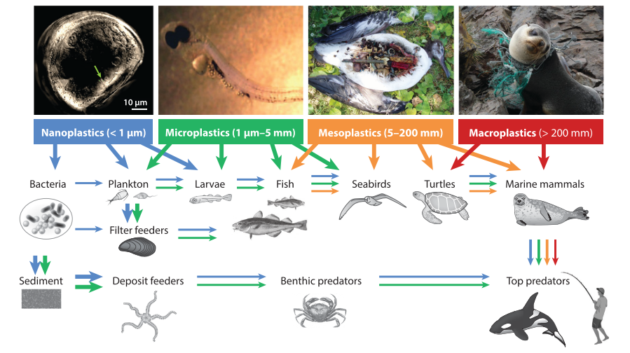
Expert elicitation ranked plastic bags, utensils and balloons the most severe ingestion risk for seabirds, sea turtles and marine mammals. Plastic utensils were expected to be ingested more frequently, followed by plastic bags and other plastic items such as food packaging, butts, caps and balloons (Wilcox et al., 2016).
Figure 1 – Uptake and possible trophic transfer of plastic pollution in marine food webs. From Worm et al. (2017)

2.2.4 Contamination risk
Other than the physical damage caused by plastic ingestion, toxic chemicals in plastic debris might also pose a risk to marine organisms. Toxicity associated with plastics can be a result of three factors: residual monomers from manufacture or toxic additives that may leach from plastic (for example: metals, bis-phenol A, phthalate and adipate plasticizers and polychlorinated biphenyls, PCBs); toxicity of intermediates in plastic degradation; and POPs (persistent organic pollutants) that are absorbed and concentrated by plastic pieces (Barnes et al., 2009; Andrady, 2011). Many of these substances are known to be persistent, bio accumulative and toxic (PBT) (Law, 2017).
The rate of sorption and accumulation of chemicals from seawater to plastic has been found to depend on the type of polymer, the physical and chemical properties of the plastic (modified by weathering and fouling that increase the affinity for sorption), the particle surface area, and the chemical exposure through the particle’s drift history (Rochman, 2015). The movement of a chemical from the water to a plastic item is mainly driven by hydrophobicity, so the more hydrophobic a material is, the greater its rate of chemical sorption and accumulation. Hydrophobicity, is measured by octanol-water partition coefficient (Kow), and it varies in plastic types in the following order: LDPE ≈ HDPE ≥ PP > PVC ≈ PS (O’Connor, Golsteijn and Hendriks, 2016). Corroborating this, Rochman et al. (2013) performed an experiment measuring sorption of organic contaminants for different plastics and found that that concentrations sorbed to HDPE, LDPE and PP (rubbery polymers) were greater than PET and PVC (glassy polymers). However, in another study it was determined that polystyrene (PS) was both a sink and source for persistent organic pollutants, sorbing greater concentrations of chemicals than PP, PET and PVC (Rochman et al., 2013). The chemical structure of polystyrene makes it easier for a chemical to diffuse into the polymer so may explain why contaminants sorb similarly to polystyrene as they do to polyethylene (Pascall et al., 2005). Size affects both the sorptive capacity and the rate at which chemicals are sorbed (Rochman, 2015). Therefore, microplastics that have a greater surface area to volume ratio and are more likely to transfer chemicals and constitute increased risk to marine organisms (Barnes et al., 2009; Rochman, 2015).
The monomer that makes the polymer itself can also be classified as hazardous. For example, polystyrene is built from the styrene monomer, which is a priority pollutant identified by the US EPA and EU because it is persistent, bioacummulative and/or toxic (Rochman, 2015). On the other hand, polyethylene and polypropylene are made from least hazardous monomers (Lithner, Larsson and Dave, 2011). PVC and high-impact polystyrene are considered carcinogenic and toxic for reproduction (Lithner, Larsson and Dave, 2011). Additionally, during the manufacturing of plastics there can be chemical byproducts, as in the production cycle of polystyrene (Rochman et al., 2015). Furthermore, chemical plastic additives are not chemically bound to the polymers, so can also leach out once in an aqueous solution. In the marine environment the most commonly found additives are: poly-brominated diphenyl ethers (PBDE), phthalates, nonylphenols (NP), bisphenol A (BPA) and antioxidants. Some of these additives are endocrine disruptors or estrogen mimics (Hermabessiere et al., 2017). PVC requires the most additives (accounting for 73% of the world production of additives), followed by polyethylene and polypropylene (10% by volume) (Lithner, Larsson and Dave, 2011).
The amount of chemicals transferred to an organism depends on how much plastic is ingested, the residence time of the plastic in the gut, the chemical concentration in the plastic and in the animal, and the repartition of toxic chemicals within the organisms (Andrady, 2011, Koelmans, 2015). This concentration of toxic chemicals in plastic can enter food chains by ingestion and be harmful for organisms. Some of the effects caused by toxic plastics include stomach ulceration, liver damage, neurological and reproductive disorders, hormone alterations and sometimes death. In one of the most environmentally relevant studies, liver stress in fish was recorded when their diets included plastics and it was intensified when the plastics had sorbed contaminants from exposure to seawater (Rochman et al., 2013). Expert elicitation to estimate contamination risk for seabirds, sea turtles and marine mammals identified that cigarette butts, hard plastic containers and food utensils posed the greatest risk (Wilcox et al., 2016).

2.2.5 Other risks
Another risk marine organisms are subject to upon encounter with plastics is harm by interaction, which includes non-entangling contact. This can cause tissue grazing and breakage of sessile invertebrates, changes in ecological assemblages following colonization of debris, and death by suffocation (Law, 2017). Plastic on the seafloor could be acting as a barrier that prevents light penetration and organic matter from settling, and that reduces oxygen exchange (Green et al. 2015 in Law). Plastic on beaches can also obstruct turtle migration (Ozdilek et al. 2006 in Law) and crab’s burrowing activity (Widmer and Hennemann 2010 in Law). Lastly, plastics floating in the water can be a substrate for microorganisms, sessile and mobile invertebrates, as well swimming animals. When these plastics travel long-distances they can be a vector for non-native and potentially invasive species.

2.2.6 Level of impact risk
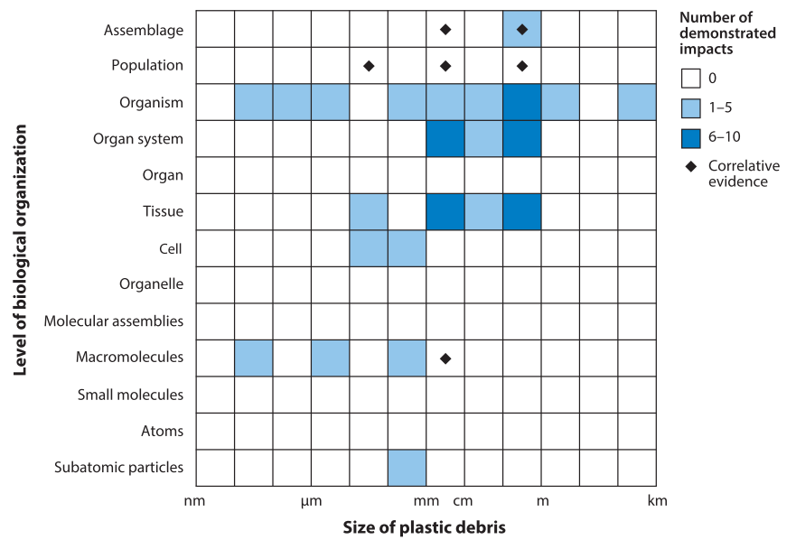
It is possible to see that biological responses from encountering plastic debris can occur at the sub-organismal, organismal and assemblage level. Rochman et al. (2016) performed an analysis of the evidence that exists for impacts of plastics at different levels of biological organization (Figure 2). They showed that more studies to demonstrate impacts at ecologically relevant levels are needed. In an effort to do this, Browne et al. (2015) reviewed the mechanisms that link the impacts on lower levels of biological organization to populations and assemblages. They suggested that microplastics reduce the health, feeding, growth and survival of ecosystem engineers, while larger debris can alter assemblages directly by killing individuals and damaging habitats, as well as recruiting novel taxa on floating items.
Figure 2 – Demonstrated impacts of plastic marine debris as a function of debris size and affected level of biological organization. Obtained from the analysis by Rochman et al. (2016).

2.3 Regulatory and other strategies to reduce single-use plastic pollution
In the 1970s, concern about the impact of plastic pollution on the environment started to rise. This led some governments to take actions to reduce the problem: the International Convention for the Prevention of Pollution from Ships was signed in 1973, and waste disposal and recycling practices improved, mostly in highly industrialized countries (Worm et al., 2017). Today, the need for more upstream and downstream strategies to minimize the impacts of plastics on marine life has been recognized (Table 6), requiring the engagement of a range of stakeholders, from governments and plastic producers to consumers and waste management organizations (Worm et al., 2017). In February 2017, the United Nations launched a Clean Seas campaign which calls for global co-operation, urges governments to implement plastic reduction policies, pushes for industry to minimize plastic packaging and redesign products, and asks citizens to change consumptive habitats of single-use plastic items (UN, 2017).
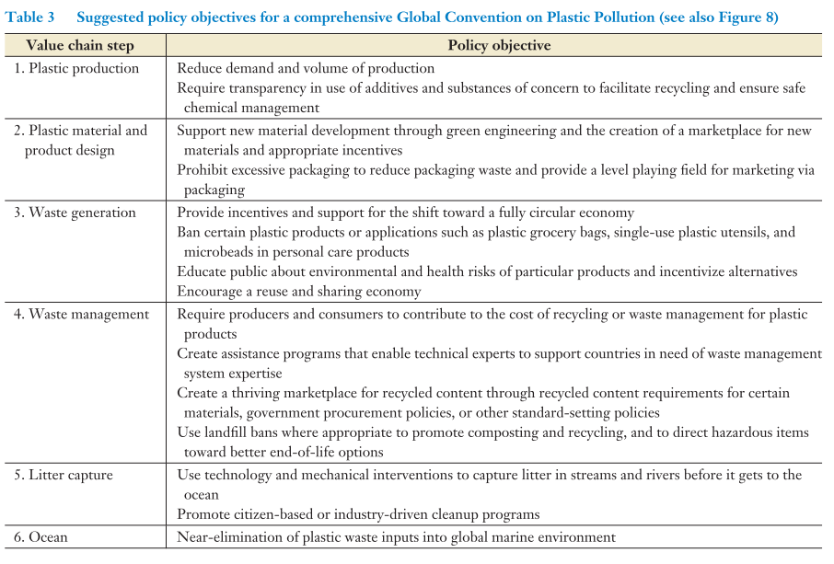
Table 2 – Various policy objectives to reduce marine plastic pollution. From Worm et al. (2017).
Some recent successful initiatives have reduced littering and improved recycling of certain single-use plastics such as PET plastic bottles through Extended Producer Responsibility and deposit-return schemes. For example, in Germany, Japan and South Africa manufacturers are responsible, either voluntarily or by law, to recycle used PET bottles (UNEP, 2018).
It is important to note that the recent drive for action by governments has largely focused on plastic bags and foamed plastic items as these are perceived as the most problematic given their impact is very visible. Different policies (partial or total bans) and economic measures (levies on suppliers, retailers, or consumers) have been developed and implemented by national and local governments around the world to reduce the use of these items. The enforcement of regulations at the national level has increased after 2015 (Figure 4) and now they are introduced in more than 60 countries, with over 140 regulations at the national and local levels (UNEP, 2018).
There is not yet sufficient information on the impacts of half of the national bans and levies implemented so far as they have been implemented only recently, or monitoring and reporting systems are absent. However, based on the remaining 50%, 30% have reported reduction in pollution and consumption and 20% have reported no to little impact, possibly because of lack of enforcement or affordable alternatives (UNEP, 2018).
Drawing on the experiences of previous policy approaches to reducing plastic pollution, the UN Environment Program has developed a 10-step roadmap for policymakers to follow (Appendix A). The work presented in this report would be of aid to complete the first step: assess baseline conditions. This includes assessing what the most problematic single-use plastics are that require attention, what is the extent of the problem, what are the impacts of plastics on areas such as environmental health, and what is the cause of the problem (UNEP, 2018).
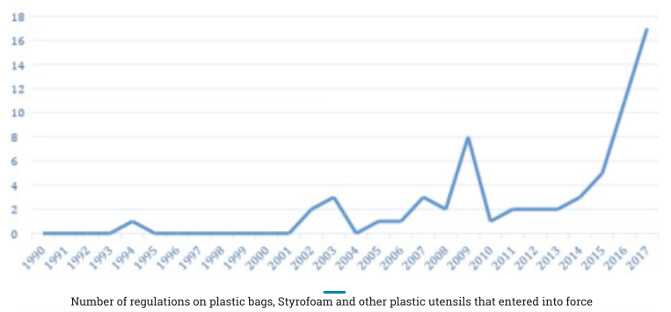
Figure 3 - Estimated number of new regulations on certain single-use plastics entering into force at the national level worldwide. From UNEP (2018).

2.3.3 Canadian context
In Canada, there have been several local bans that have entered into effect to reduce the use of plastic bags. Starting in 2007, a ban on plastic bags in Leaf Rapids, Manitoba was implemented. In 2010, bans in the Municipality of Wood Buffalo, Alberta on single-use plastic bags (<571µ thickness) and in Thompson, Manitoba on all plastic shopping bags entered into effect. The latest bans were in January 2018 when all plastic bags <50µ thickness were banned in Montreal (UNEP, 2018) and in July 2018 when Victoria implemented a similar ban. Additionally, Canada banned the production of microbead plastics as they were considered toxic to human health or the environment and enacted the ban on the sale of products that contain these particles, such as shower fells, face scrubs and toothpaste by June 2018.
In May 2019 the city of Vancouver released its “Single-use item reduction strategy 2018-2025” (City of Vancouver, 2018). The strategy includes by-law amendments beginning in November 1, 2019 that will prohibit the distribution by business license holders of expanded polystyrene foam cups and take-out containers, as well as plastic straws, and single-use utensils unless requested by the customer. Additionally, it includes by-law amendments that require business license holders to have plans to reduce the number of cups and plastic/paper bags they distribute. Furthermore, actions include introducing a requirement for single-use cups, take-out containers, straws and utensils to be recyclable or compostable.
Finally, more Canadian consumers, businesses and institutions are announcing voluntary restrictions on disposable straws, including bars and restaurants in Toronto, restaurants in Prince Edward Island and universities (Chung, 2018).

2.3.4 Strategies implemented by other universities
Several universities have started to participate the global plastic reduction movement by implementing some of the strategies outlined above to reduce the consumption of single-use plastics. These movements primarily start in the food sector, or in other sectors such as labs (Table 3).
Table 3 – Strategies implemented by universities globally to reduce single-use plastic waste entering the marine environment
University | Year | Strategy details (actions, alternatives offered, intended or measured impact)
University of Guelph | Fall 2018 | Remove all single-use plastic straws and bags from all in-house retail and restaurant operations.  Will eliminate 175,000 straws from the landfill.
Western University | Fall 2018 | Stop offering bags and straws
University of Winnipeg | 2009 | First university in Canada to ban the sale of water bottles on campus
University of Vermont | 2013 | Campus-wide ban on the sale of bottled water.  Unsuccessful in significantly reducing plastic (Berman and Rachel, 2015)
University of Plymouth | 2017 | Ban the use of plastic straws on campus
University of Portland | April 2018 | Ban plastic straws at all food or beverage outlets on campus (Supported by giving out 400 reusable straws and having on-demand dispensers with paper straws)  Eliminated 9,000 straws a month.
Chico State university | April 2018 | Ban plastic straws (Supported by having paper straws coated in beeswax upon request, stainless steel straw kits sold at $1.25)  Eliminated 130,000 straws every year.
Hong Kong University | July 2017 | Ban on sale of plastic water bottles. (Supported by free water fountains, rental service of cutlery and plates for use in college canteens, tool-kit to organize events with no plastic bottles)
India’s University Grants Comission | 2018 | Ban take-away coffee cups, lunch wrapped in disposable plastic packaging, plastic bags, disposable food service cups, plates, containers made in polystyrene foam and plastic straws. Restrict single-use plastic water bottle and encourage use of refillable bottles instead

3 UBC Single-use plastics data collection

3.1 Methods of data collection and extrapolation

3.1.1 Food businesses
The approach taken to investigate the food sector’s use of plastics involved obtaining procurement details or estimates of the top single-use plastic items bought and distributed during one year by different food businesses on campus. Managers or procurement officers for UBC Food Services, the AMS, and other independent businesses in the AMS Student Nest, The Robert H. Lee Alumni Centre and the UBC Trolley bus loop were contacted directly by email or approached in person first to obtain this information. Detailed procurement information was received from UBC Food Services and the AMS businesses, and only some of the other independent businesses - including The Boulevard Coffee Roasting Co., Liquid Nutrition and Loafe Café - were able to provide details or estimates of yearly plastic use.
Some of the smaller businesses only provided estimates of the number of items they used during an average day or week of the year and this was used to estimate an amount for the whole year. Days or weeks during the summer terms were considered to be approximately half as busy as those during the fall and winter terms given the greater number of students and faculty on campus. The number of days for each of these terms (122 total in the fall and winter terms and 56 in the summer terms) was considered when calculating estimates of yearly use.
Single-use plastic items were classified under 14 item types: hot cups, lids of hot cups, cold cups, lids of cold cups, cutlery (all types of forks, knives and spoons), straws, food containers, lids of food containers, sauce cups, lids of sauce cups, bags, gloves, film and bottles. Additionally, information on what type of plastic resin the items were made out of was also most often obtained from communicating with the parties providing the procurement details, or by examining the items or their packaging boxes in person. When it was not possible to obtain the information in either of these two ways, other information that was available online on what material similar items were most likely made out of was used to assume their composition.
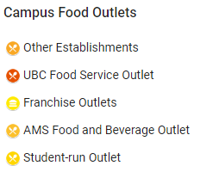
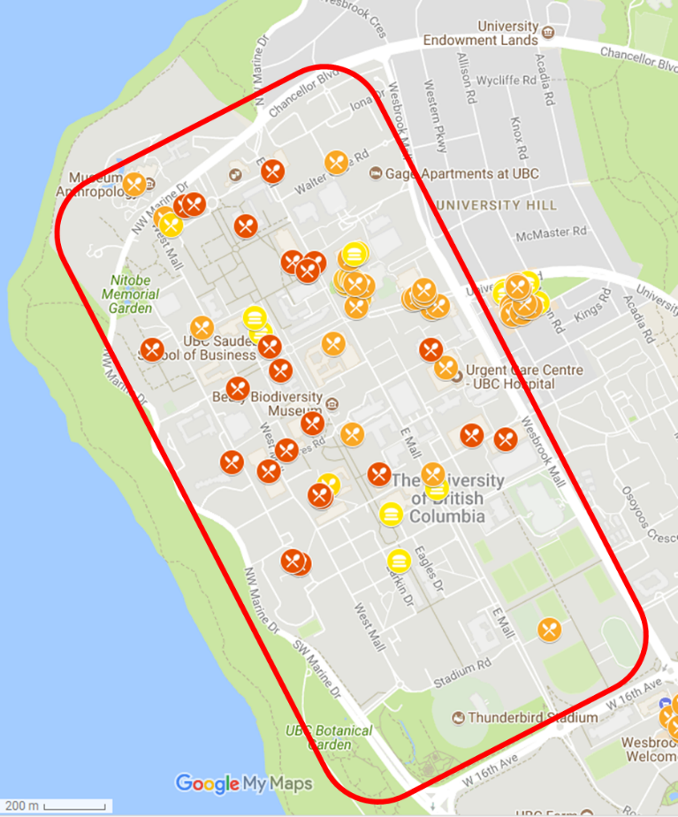
The numbers that were obtained represented a vast majority but not all of the food businesses on campus, so the results had to be extrapolated to approximate the total quantities of items used across the university. This was done based on the number of individual food business locations that were included in the values obtained (36 units considering those businesses managed by UBC Food Services and AMS), and by considering how many other food businesses are found on campus to scale quantities based on that (31 more businesses based on a food asset map available online; Figure Appendix B). It was assumed that all businesses, irrespective of their size and location, receive the same customer traffic and have the same types of plastic items to distribute to their customers as those sampled.
Figure 4 – Map of food outlets on campus outlining the area considered for the scope of this assessment. Modified from map obtained at www.food sustain.ubc.ca/foodassetmap

3.1.2 The UBC Bookstore
To investigate the top single-use plastic used at the UBC Bookstore, the Merchandise Manager was contacted to obtain procurement details for one year. Information was obtained for their top two items: plastic bags and water bottles. Given these items were also within the top plastic items used by the food sector, the values were reported together with the food sector’s.

3.1.3 Research labs
In order to investigate plastic use in research laboratories at UBC, details on the procurement of plastic lab disposables by different labs during a year were sought. A subset of lab managers at the Michael Smith Laboratories (MSL) was contacted by email to ask about this, given certain contacts had already been established in this research unit. Additionally, members of the Green Labs Committee were contacted by email and phone to enquire about this, including a representative in Financial Operations, Supply Management.
Information on procurement of top plastic items was received from four labs: a biochemistry and molecular Biology lab, a cell and bioprocess engineering lab, a quantitive proteonomics lab and a plant specialized metabolism lab. Quarterly reports on the product sales of UBC’s preferred Scientific Supplier, VWR, were also obtained from UBC’s Financial Operations office. Additionally, details on the recycling programs in place for labs at UBC, including polystyrene foam, were also received from these contacts.
The VWR quarterly reports included information on total number of cases or boxes bought of plastic disposables (under the Plasticware category), plastic gloves (under Safety) and pipette tips (under Liquid Handling). These were consolidated for the months of January-December 2017. Further details on number of units per package, plastic resin type and price were extracted from the vendor’s website (www.vwr.ca) using the VWR Catalog numbers.
All lab plastic items were classified under 15 item types: pipette tips, microcentrifuge tubes, larger centrifuge tubes and test tubes, serological pipettes, gloves, petri dishes, plates, fly vials, plugs, weigh boats, tools, transfer pipettes, flasks and bottles. Information on the type of plastic resin for individual labs were provided by the lab managers when known or indicated on the product or packaging. When these details were not provided, plastic composition was assumed based on other information that was available online.
Extrapolation of the result was carried out based on the estimate shared by Financial Operations that VWR represented 25-50% of overall scientific consumables supply at UBC. The total number of labs at MSL, which is 40 considering Faculty and Associate Members, was also used to extrapolate the amount of plastic used by that research centre. An assumption of this extrapolation method was that all labs at UBC and MSL, irrespective of their size and research focus, use the same type and number of plastic items as the labs captured in the numbers obtained.

3.1.4 Information on recyclability
Details on the recyclability of specific plastic items were obtained by contacting the waste management company that receives UBC’s recyclable materials, Cascades Recovery. They provided details on the probability of an item being successfully recycled, with ‘Low’ meaning items are never recycled, and ‘High’ meaning they are always recycled. Additionally, they communicated the current location of the end processing of plastic items (Vancouver area, elsewhere in Canada or International) and the recycling process they presently undergo (whether they are recycled to new products, downcycled or used as fuel). It was noted that this can change at any time based on the markets for plastic items that are always moving. It is important to highlight that this was information received from only one local recycling services company, and details and procedures could be different for other companies.

3.2 Results from data collection and extrapolation

3.2.1 Food businesses & the UBC Bookstore
Figure 2 shows the single-use plastics consumed in a year by food businesses and the UBC Bookstore, based on procurement details and extrapolation estimates. Cutlery is the number one plastic item consumed by these sectors. Hot and cold coffee cups and vinyl gloves follow and together comprise the top five items consumed.
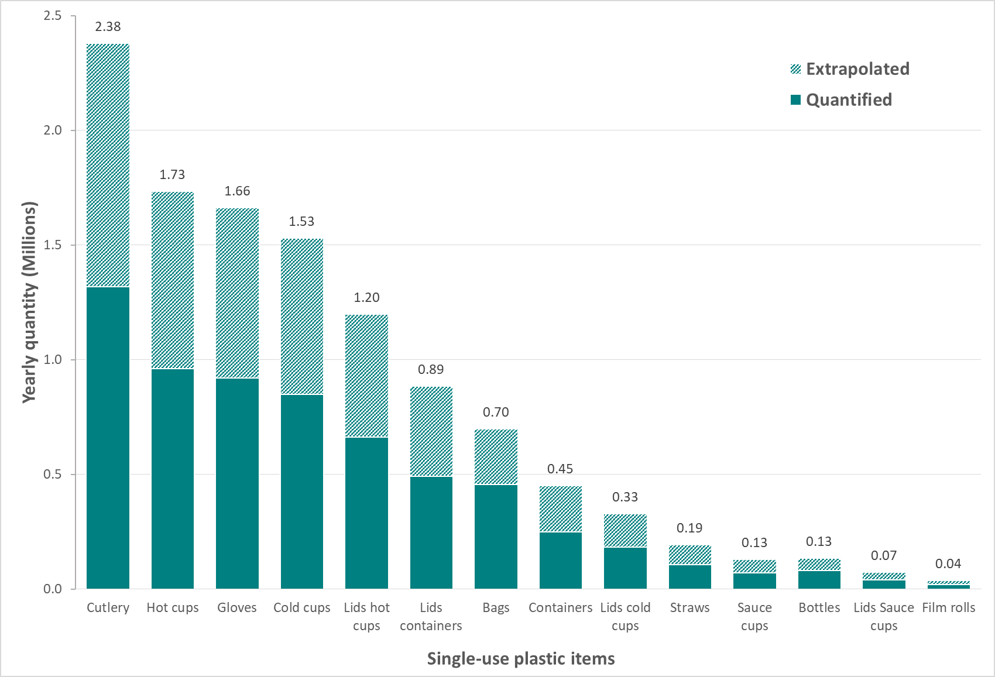
Figure 2 – Total numbers of single-use plastic items consumed by food businesses and the UBC bookstore. Dark shading indicates the quantities obtained from procurement details from the UBC Food Services and AMS food businesses (36 units in total), light shading is the extrapolation considering there are other businesses on campus (31 more businesses; 67 in total).

3.2.2 Research labs
Labs at the MSL consumed pipette tips in higher quantities than any other plastic disposables. Tubes of different sizes (micro centrifuge, centrifuge and test tubes) were also found to be within the most commonly used items, as were serological pipettes and gloves (Figure 3). Similar trends were found from the VWR sales reports, with the addition of petri dishes within the top six items consumed (Figure 4). It was also found that Styrofoam collected for recycling over the course of almost 7 years of the pilot recycling program (Sep 2011-Feb 2018) totalled 1223 m³ or 23 tonnes in weight.
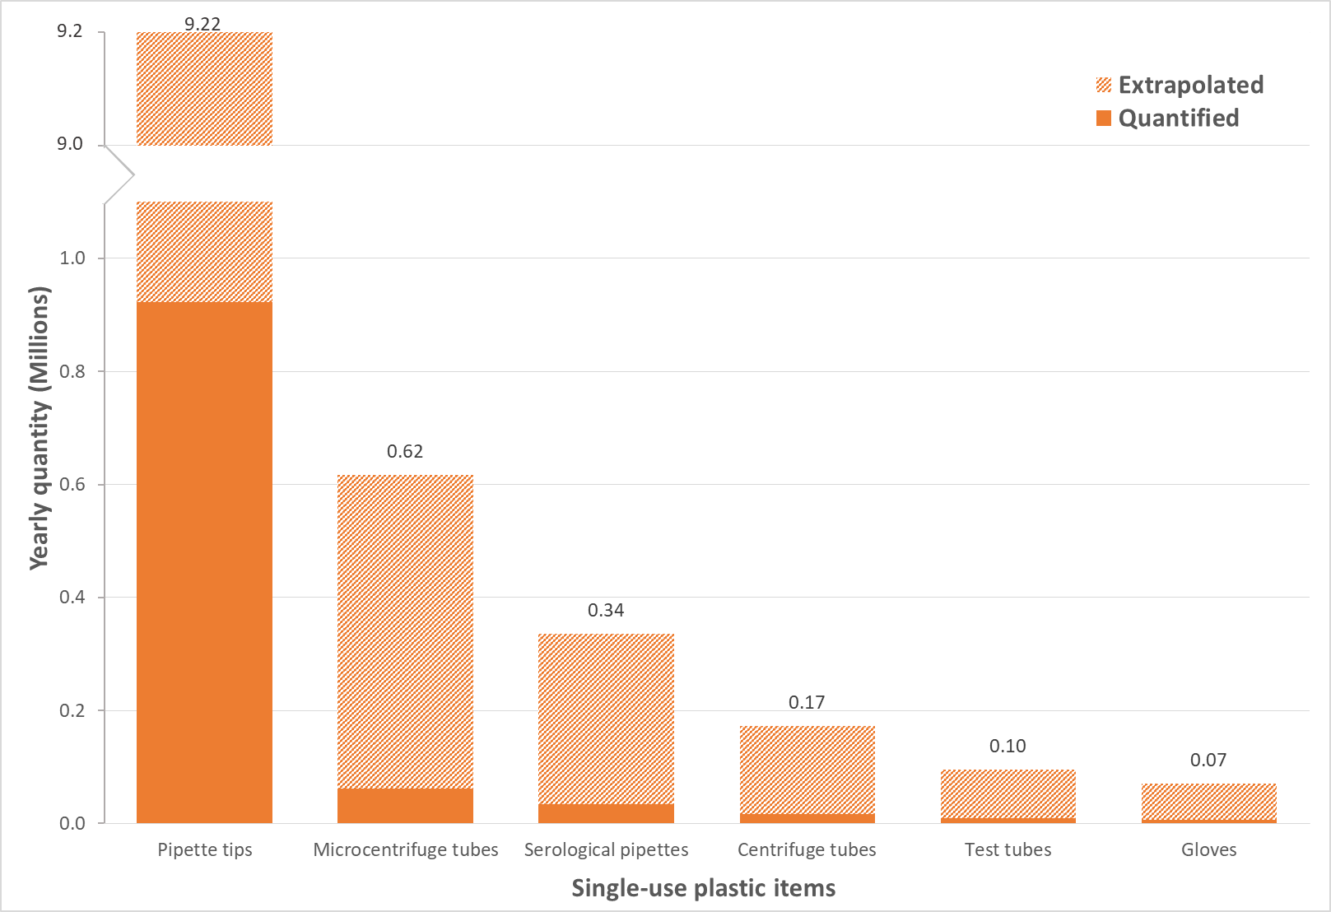
Figure 3 – Total numbers of top six single-use plastic items consumed by labs in the Michael Smith Laboratories group. Dark shading indicates the labs contacted directly (four labs), light shading is the extrapolation considering other labs in that research unit (36 more labs; 40 in total).
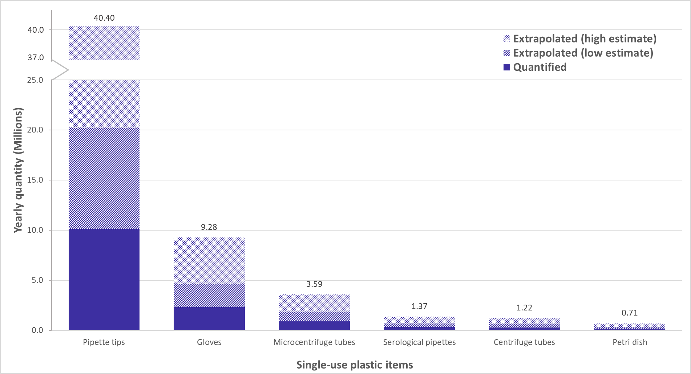
Figure 4 – Total numbers of top six single-use plastic items purchased at UBC in one year. Dark shading indicates the disposables purchased from UBC’s preferred supplier, light shadings include the extrapolation considering other suppliers (from 50-75% of items)

3.3 Recyclability of single-use plastic items consumed at UBC
Items made from plastic resin PETE #1 as well as bottles of HDPE #2 are always recycled into new products in the Vancouver Area. Items made from PVC #3, are never recycled but used as fuel in the Vancouver Area. Items that contain LDPE #4 plastic can either be used as fuel or recycled in the Vancouver Area or internationally. Plastics made from PP #5 are either locally recycled or used as fuel, while plastics made from PS #6 and other plastics #7, are never recycled but used as fuel locally instead. Table 4 provides a breakdown of recyclability for the single-use plastics found to be consumed at UBC. Communication with the company highlighted that, currently, plastics #1, #2 and #4 are the easiest to recycle and if an item does not have a symbol it is difficult to tell what it is made out of and may not be recycled
Table 4 – Summary of recyclability details for different single-use plastic items used at UBC provided by Cascades Recovery.
Common plastic type | Plastic item | Recyclability at UBC
Common plastic type | Plastic item | Probability of recycled to new plastic products | End processing location | Any known information of recycling process
PETE #1 | Bottles | High | Vancouver area | Recycled into new products
PETE #1 | Food containers | High | Vancouver area | Recycled into new products
PETE #1 | Food container lids | High | Vancouver area | Recycled into new products
PETE #1 | Cold cups | High | Vancouver area | Recycled into new products
PETE #1 | Cold cup lids | High | Vancouver area | Recycled into new products
HDPE #2 | Bottles | High | Vancouver area | Recycled into new products
PVC #3 | Gloves | Low | Vancouver area | Fuel
PVC #3 | Film | Low | Vancouver area | Fuel
LDPE #4 | Coffee cup linings | Low | Vancouver area | Fuel/coffee cup itself could be pulped for fibre recovery
LDPE #4 | Bags ¹ | Variable  (low – high) | International | Downcycled / fuel ²
LDPE #4 | Biodegradable bags ¹ | Low | Vancouver area | Fuel
LDPE #4 | Paper bags with window¹ | High | International | Recycled into new fibre products²
LDPE #4 | Film ¹ | High | Vancouver area | Recycled
PP # 5 | Cutlery | Low | Vancouver area | Fuel
PP # 5 | Coffee cup lids | High | Vancouver area | Recycled into new products
PP # 5 | Food containers | High | Vancouver area | Recycled into new products
PP # 5 | Cold cups | High | Vancouver area
PP # 5 | Food container lids | High | Vancouver area | Recycled into new products
PP # 5 | Straws | Low | Vancouver area | Fuel
PP # 5 | Bottle caps | High | Vancouver area | Recycled into new products
PP # 5 | Pipette tips ¹ | Undetermined | Vancouver area | Undetermined
PP # 5 | Tubes (microcentrifuge, centrifuge) ¹ | Undetermined | Vancouver area | Undetermined
PS # 6 | Food containers | Low | Vancouver area | Fuel
PS # 6 | Food container lids | Low | Vancouver area | Fuel
PS # 6 | Coffee cup lids | Low | Vancouver area | Fuel
PS # 6 | Straws | Low | Vancouver area | Fuel
PS # 6 | Sauce cups | Low | Vancouver area | Fuel
PS # 6 | Serological pipettes ¹ | Low | Vancouver area | Fuel
PS # 6 | Petri dishes | Low | Vancouver area | Fuel
 | Tubes ¹ | Low | Vancouver area | Fuel
Other #7 | PLA plastics (cups, containers) ¹ | Low | Vancouver area | Compost facility (check capability with your organics provider)
Other #7 | Gloves (nitrile) | Low | Vancouver aeea | Fuel
¹ Should not be included in container stream
² Varies based on market conditions

4 Impact of single-use plastics on marine life

4.1 Framework
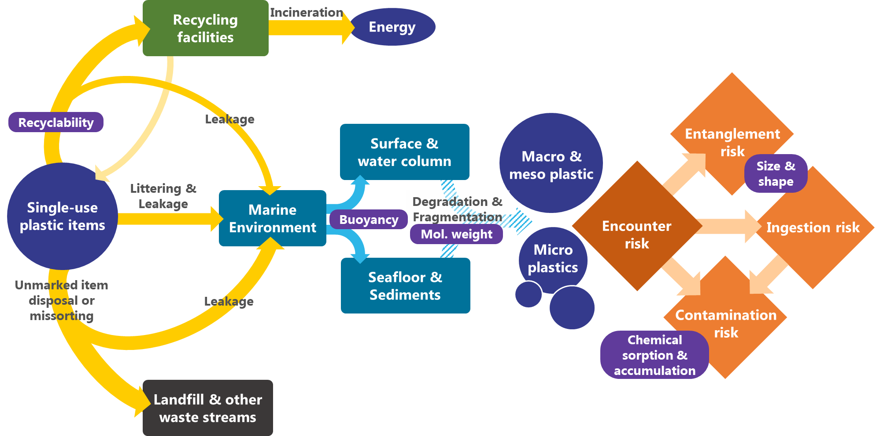
Based on the literature reviewed, the following framework was designed to better understand the ways that plastic waste can enter the marine environment and the pathways through which it can pose a risk on marine life.
Figure 5 – Conceptual representation of framework outlining the possible ways single-use plastic items can enter, move and transform in the marine environment, and what type of risk they can pose on marine life. Navy circles represent plastic items in different forms, different colored rectangles are possible endpoints, and orange squares represent risk elements. Arrows represent processes and movements, and properties of plastic items and plastic types that are contributing to these are represented as purple boxes

4.2 Risk assessment model
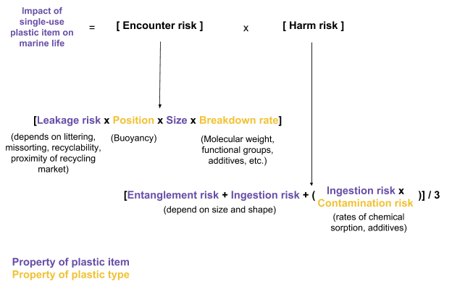
Furthermore, the following model was proposed to compare the impact of different plastic items on marine organisms. The potential impact is subject to encounter risk: the probability of a marine organism encountering a plastic item in the marine environment. This in turn depends on the likelihood of it first leaking into the marine environment, its position in the water column, its size and breakdown rate. Additionally, the severity of impact depends on the type and probability of harm being caused to the organism once it encounters the plastic item. This is an average of entanglement risk, ingestion risk and contamination risk. The model considers both properties of the plastic items and the plastic resin type.
Figure 6 – Conceptual representation of marine life impact assessment model. Factors contributing to encounter and harm risk are identified, and color coding represents whether the characteristic is a property of a plastic item or the plastic type it is made out of.
An initial attempt was made to estimate the harm risk for different plastic items that are commonly used at UBC. Contamination risk was determined based on the plastic resin type, as these have different rates of chemical sorption, hazardous monomers and additives. PETE and PP items were considered to pose a moderate risk as they sorb lower concentrations of chemicals; PVC was considered to pose a high risk because even if it sorbs less chemicals it has harmful monomers and additives; HDPE, LDPE and PS were considered to pose a high risk as they sorb high concentrations of chemicals.
Entanglement and ingestion risk were estimated based on expert elicitation rankings, and the size and shape of the plastic items. Items that have loops and soft three-dimensional structures such as gloves and bags were considered to have a high entanglement risk, more rigid structures such as cups and containers were considered to have a moderate risk as animals might still get stuck in them, and flat items were classified as presenting a low risk. The risk of ingestion and physical harm was greater for sharp objects, such as cutlery and straws, and items that can be easily ingested such as bottle caps, and bags. Risks were given values form 0 to 1 and combined as outlined in the model to obtain one harm risk score per item (Table 5). This was compared with the relative ranking by Wilcox et al. (2016) of the most severe expected impact across bird, turtle and mammal taxa of item categories that most closely matched the single-use items under assessment (Table 6). The similarity with these scores corroborates the Combined Harm risk values as an appropriate measure to quantify marine impact. Table 7 aggregates the various pieces of information by item, highlighting the most harmful, the most numerous and the least recyclable single-use plastic items.
Table 5 – Estimates on likelihood of single-use plastic items posing an entanglement (E), ingestion (I) and contamination (C) risk to marine organism. The combined harm risk score is calculated as ((E) + (I) + (I x C))/3. Color codes represent levels of relative impact from 0.16 -1.
 | Plastic item | Common plastic type at UBC | Ingestion risk | Contamination risk | Entanglement risk | Combined Harm risk
Food and bookstore | Cutlery | PP | 1 | 0.5 | 0.5 | 0.67
Food and bookstore | Coffee cup linings | LDPE | 0.25 | 1 | 0.5 | 0.33
Food and bookstore | Coffee cup lids | PS | 0.5 | 1 | 0.1 | 0.37
Food and bookstore | Gloves | PVC | 1 | 0.75 | 1 | 0.92
Food and bookstore | Cold cups | PETE | 0.25 | 0.5 | 0.5 | 0.29
Food and bookstore | Cold cups | LDPE | 0.25 | 1 | 0.5 | 0.33
Food and bookstore | Cold cups | PP | 0.25 | 0.5 | 0.5 | 0.29
Food and bookstore | Cold cup lids | PETE | 0.5 | 0.5 | 0.1 | 0.28
Food and bookstore | Cold cup lids | PS | 0.5 | 1 | 0.1 | 0.37
Food and bookstore | Bags | LDPE | 1 | 1 | 1 | 1.00
Food and bookstore | Bags | LDPE window | 1 | 1 | 0.5 | 0.83
Food and bookstore | Bags | Biodegradable LDPE | 1 | 1 | 1 | 1.00
Food and bookstore | Bags | PP | 1 | 0.5 | 1 | 0.83
Food and bookstore | Food containers | PP black | 0.25 | 0.5 | 0.5 | 0.29
Food and bookstore | Food containers | PETE | 0.25 | 0.5 | 0.5 | 0.29
Food and bookstore | Food containers | LDPE | 0.25 | 1 | 0.5 | 0.33
Food and bookstore | Food container lids | PS | 0.5 | 1 | 0.1 | 0.37
Food and bookstore | Food container lids | PP | 0.5 | 0.5 | 0.1 | 0.28
Food and bookstore | Food container lids | PETE | 0.5 | 0.5 | 0.1 | 0.28
Food and bookstore | Straws | PP | 1 | 0.5 | 0.75 | 0.75
Food and bookstore | Straws | PS | 1 | 1 | 0.75 | 0.92
Food and bookstore | Bottles | PETE | 0.25 | 0.5 | 0.1 | 0.16
Food and bookstore | Bottles | HDPE | 0.25 | 1 | 0.1 | 0.20
Food and bookstore | Bottle caps | PP | 1 | 0.5 | 0.5 | 0.67
Food and bookstore | Sauce cups | PS | 1 | 0.5 | 0.1 | 0.53
Food and bookstore | Sauce cup lids | PETE | 1 | 0.75 | 0.1 | 0.62
Food and bookstore | Film | PVC | 1 | 1 | 0.1 | 0.70
Food and bookstore | Film | LDPE | 1 | 1 | 0.1 | 0.70
Labs | Pipette tips | PP | 1 | 0.5 | 0.5 | 0.67
Labs | Tubes | PP | 0.75 | 0.5 | 0.5 | 0.54
Labs | Tubes | PS | 0.75 | 1 | 0.5 | 0.67
Labs | Serological pipettes | PS | 0.5 | 1 | 0.1 | 0.37
Labs | Gloves | Nitrile or PVC | 1 | 0.75 | 1 | 0.92
Labs | Petri dishes | PS | 0.5 | 1 | 0.1 | 0.37
Table 6 – Comparison of calculated combined harm risk score and relative expected impacts based on rankings determined for the most common litter items found along the world’s coastlines in an expert elicitation study (Wilcox et al., 2016). Color coding and bars represent relative amounts within each scale for easier comparison.
Table 7 – Summary of combined harm risk scores, extrapolated quantities of each plastic item consumed, an impact score calculated by multiplying the harm risk with the extrapolated amount, and the recyclability (symbols represent low, variable/uncertain, and high recyclability) for each item.

5 Discussion and recommendations
This research explores UBC’s contribution to the global issue of ocean plastics. It provides a better understanding of the quantities of single-use plastics consumed on campus, their recyclability and their potential impact on marine life in case they leak into the marine environment. It reiterates the need to consider the characteristics of plastic items, the plastic type they are made out of and their recyclability in order to make procurement decisions that pose a lower threat on marine organisms in the marine environment surrounding the university.
From our analyses it was determined that certain plastic items are of greater concern for marine life and should be prioritized in reduction strategies. For example, polyvinyl chloride (PVC, #3) gloves and low-density polyethylene (LDPE, #4) plastic bags are the items that represent the highest risk to marine life and they are either not recycled or shipped internationally for recycling, which increases the probability of them ending up in the marine environment. Gloves are upon the most consumed items in the food sector, and plastic bags are consumed in both the food sector and the Bookstore. Additionally, plastic cutlery made from polypropylene (PP, #5) was the most consumed single-use item at UBC; and given it it is not recycled and poses a relatively high risk on marine life it represents a significant problem. Similarly, coffee cups are the second most consumed item, their LDPE lining also isn’t recycled and constitutes a moderate risk to marine organisms.
Our analysis also highlights that, in general, items such as cold cups, to-go food containers, sauce cups and lids are the most problematic when they are made of polystyrene (PS) plastic. This is because the items are not recycled in Vancouver and pose a high contamination risk in the ocean. These items should be avoided when possible and alternative products should be chosen instead. Containers made from polyethylene terephthalate (PETE) or PP are better options as they are less toxic and are more likely to be recycled. However, given that food waste contamination is an important issue in the container recycling stream, the ideal solution would be to substitute as many of these items with materials that are fully compostable at UBC. These include plain, uncoated paper products such as paper bags, and paper plates; uncoated wood utensils and fibre-based (paper, wood or bamboo) products that are certified compostable to BPI or CCME/BNQ or other recognized compostable standards. Items marked as “compostable plastic” and “biodegradable plastic” such as plastic cups, cutlery, food containers and bags are not compatible with UBC’s composting system and regional composting systems (UBC Sustainability, 2016) and should not be considered as good alternatives.
Lab plastic use was also found to be problematic as the most-used items are largely not accepted for recycling and can be quite harmful for marine life if they end up in the ocean. Gloves pose the highest risk and similarly to the food sector, they are among the most highly consumed items in research labs. Pipette tips, made from PP, pose a severe ingestion risk, and constitute the highest amount of plastic waste from research labs. Tubes, serological pipettes and petri dishes are also consumed in high numbers and are quite harmful to marine life, especially when made from PS due to the higher contamination risk this material poses. Lab disposables are not currently accepted for recycling because of the probability that they could have been in touch with biohazardous or toxic chemicals. UBC labs have designated waste streams for contaminated materials that ensure they are disposed in the appropriate way and in specialized facilities, so as long as labs do proper sorting this shouldn’t be a problem as perceived. Certain pilot recycling programs, such as for Styrofoam and soft plastics, have been initiated but it does still remain a problem that a lot of lab disposable items are not marked with their plastic type.
Based on our conclusions, we recommend that UBC food outlets and the bookstore take the following actions:
- Eliminate the distribution of LDPE plastic bags on campus. Increase the stock of reusable bags to provide as an alternative. If necessary, provide a single-use bag option that is compostable at UBC.
- Reduce the use of gloves when no safety concerns exist, and investigate a campus-wide recycling program
- Eliminate the use of plastic disposable cutlery and straws by providing reusable or fully compostable options (as per UBC composting facility requirements outlined above). This has already been initiated by UBC Food Services and other food outlets should follow suit.
- Reduce the consumption of coffee cups and lids by providing options for reusable cups. Default to offering a ceramic in-store cup and partner with the MugShare program to a provide sustainable take-out option.
- Eliminate the use of PS plastic (currently used in coffee cup lids, cold cup lids, container lids, and sauce cups). Substitute them with compostable items (as per UBC composting facility requirements outlined above) or clear PETE or PP alternatives.
- Only choose plastics marked with the corresponding recycling code, and avoid biodegradable or compostable plastics as they are not compatible with UBC's composting system.
For research labs at UBC, given these sector-specific considerations, we recommend the following actions:
- Reduce the consumption of plastic disposables wherever possible (e.g. reuse after washing and sterilizing, or switch to materials such as glass).
- Ensure that items purchased are marked with the corresponding recycling code, and when choosing between materials, choose polypropylene (PP) over polystyrene (PS).
- Implement a program for labs that do sterile work to partner with non-sterile lab to re-use their plastic items.
- Reuse gloves when procedures allow it and no safety concerns exist.
- Investigate and implement more pilot recycling programs for lab disposables.
- In order for these to be effective, develop mandatory training units for all new and existing lab users to learn how to wash and sort items correctly.

6 Next Steps
This work has helped to further understand the issue at hand and what strategies have been pursued by other institutions to reduce plastic pollution to make the previous recommendations, but it is important to investigate the opportunities and barriers to implement these changes at UBC. The following have been identified as ideas that could be pursued to support these efforts, potentially as further SEEDS or Ocean Leaders projects:
- Investigation on the availability and cost of alternative items across all sectors that would be less harmful for marine life and compatible with the composting facilities at UBC.
- Creation of more detailed guidelines for businesses and suppliers that outline these requirements.
- Research and implementation of various possible regulatory or economic strategies at UBC to reduce the procurement and consumption of single-use plastics.
- A feasibility assessment for a program to decrease lab plastic waste through reduction, recycling or reusing strategies. There is a potential for reutilization of plastic materials between labs that have different needs concerning sterility that needs to be further explored.
- Investigation on the use of plastics that are used for wrapping products for shipment and transportation to UBC (these normally include plastic film, packaging bands and plastic bags that pose a high entanglement risk for ocean life) in the food sector as well as labs to develop guidelines to request more sustainable shipment options from suppliers.

References
(UNEP), U. N. E. P. (2018) Single-use plastics, A Roadmap for Sustainability.
Andrady, A. L. (2011) ‘Microplastics in the marine environment’, Marine Pollution Bulletin. Elsevier Ltd, 62(8), pp. 1596–1605. doi: 10.1016/j.marpolbul.2011.05.030.
Barnes, D. K. A. et al. (2009) ‘Accumulation and fragmentation of plastic debris in global environments’, Philosophical Transactions of the Royal Society B: Biological Sciences, 364(1526), pp. 1985–1998. doi: 10.1098/rstb.2008.0205.
Beaty, F. and Davis, K. (2018) ‘UBC Plastics : A short path to the ocean’.
Bergmann, M. (2015) Marine Anthropogenic Litter. Edited by M. Bergmann, M. Klages, and L. Gutow. Springer Open.
Browne, M. A. et al. (2015) ‘Linking effects of anthropogenic debris to ecological impacts’.
Corcoran, P. L. (2015) ‘Benthic plastic debris in marine and fresh water environments’, Environmental Sciences: Processes and Impacts. Royal Society of Chemistry, 17(8), pp. 1363–1369. doi: 10.1039/c5em00188a.
Geyer, R., Jambeck, J. R. and Law, K. L. (2017) ‘Production, uses, and fate of all plastics ever made’, Science Advances, 3(7), p. 5. doi: 10.1126/sciadv.1700782.
Hermabessiere, L. et al. (2017) ‘Chemosphere Occurrence and effects of plastic additives on marine environments and organisms : A review’, 182. doi: 10.1016/j.chemosphere.2017.05.096.
Jambeck, J. R. et al. (2015) ‘Plastic waste inputs from land into the ocean’, American Association for the Advancement of Science, 347(6223), pp. 768–771. doi: https://doi.org/10.1126/science.1260352.
Kerr, A. and Cowling, M. J. (2003) ‘The effects of surface topography on the accumulation of biofouling’, Philosophical Magazine, 83(24), pp. 2779–2795. doi: 10.1080/1478643031000148451.
Keshavarz, T. and Roy, I. (2010) ‘Polyhydroxyalkanoates: bioplastics with a green agenda’, Current Opinion in Microbiology. Elsevier Ltd, 13(3), pp. 321–326. doi: 10.1016/j.mib.2010.02.006.
Law, K. L. (2017) ‘Plastics in the Marine Environment’, The Annual Review of Marine Science, (9), pp. 205–229. doi: 10.1146/annurev-marine-010816-060409.
Li, W. C., Tse, H. F. and Fok, L. (2016) ‘Plastic waste in the marine environment: A review of sources, occurrence and effects’, Science of the Total Environment, 566–567, pp. 333–349. doi: 10.1016/j.scitotenv.2016.05.084.
Lithner, D., Larsson, Å. and Dave, G. (2011) ‘Science of the Total Environment Environmental and health hazard ranking and assessment of plastic polymers based on chemical composition’, Science of the Total Environment, The. Elsevier B.V., 409(18), pp. 3309–3324. doi: 10.1016/j.scitotenv.2011.04.038.
O’Brine, T. and Thompson, R. C. (2010) ‘Degradation of plastic carrier bags in the marine environment’, Marine Pollution Bulletin. Elsevier Ltd, 60(12), pp. 2279–2283. doi: 10.1016/j.marpolbul.2010.08.005.
O’Connor, I. A., Golsteijn, L. and Hendriks, A. J. (2016) ‘Review of the partitioning of chemicals into different plastics : Consequences for the risk assessment of marine plastic debris’, MPB. Elsevier Ltd, 113(1–2), pp. 17–24. doi: 10.1016/j.marpolbul.2016.07.021.
Pascall, M. A. et al. (2005) ‘Uptake of polychlorinated biphenyls (PCBs) from an aqueous medium by polyethylene, polyvinyl chloride, and polystyrene films’, Journal of Agricultural and Food Chemistry, 53(1), pp. 164–169. doi: 10.1021/jf048978t.
Pauli, N. C. et al. (2017) ‘Macrofouling communities and the degradation of plastic bags in the sea: An in situ experiment’, Royal Society Open Science, 4(10). doi: 10.1098/rsos.170549.
Rochman, C. M. et al. (2013) ‘Long-term field measurement of sorption of organic contaminants to five types of plastic pellets: Implications for plastic marine debris’, Environmental Science and Technology, 47(3), pp. 1646–1654. doi: 10.1021/es303700s.
Rochman, C. M. et al. (2013) ‘Polystyrene Plastic: A Source and Sink for Polycyclic Aromatic Hydrocarbons in the Marine Environment’, 47, pp. 13976–13984. doi: 10.1021/es403605f.
Rochman, C. M. et al. (2016) ‘The ecological impacts of marine debris: Unraveling the demonstrated evidence from what is perceived’, Ecology, 97(2), pp. 302–312. doi: 10.1890/14-2070.1.
Rummel, C. D. et al. (2017) ‘Impacts of biofilm formation on the fate and potential effects of microplastic in the aquatic environment’, Environmental Science and Technology Letters, 4(7), pp. 258–267. doi: 10.1021/acs.estlett.7b00164.
Shah, A. A. et al. (2008) ‘Biological degradation of plastics: A comprehensive review’, Biotechnology Advances, 26(3), pp. 246–265. doi: 10.1016/j.biotechadv.2007.12.005.
Sivan, A. (2011) ‘New perspectives in plastic biodegradation’, Current Opinion in Biotechnology. Elsevier Ltd, 22(3), pp. 422–426. doi: 10.1016/j.copbio.2011.01.013.
Song, J. H. et al. (2009) ‘Biodegradable and compostable alternatives to conventional plastics’, Philosophical Transactions of the Royal Society B: Biological Sciences, 364(1526), pp. 2127–2139. doi: 10.1098/rstb.2008.0289.
Sudhakar, M. et al. (2007) ‘Biofouling and biodegradation of polyolefins in ocean waters’, Polymer Degradation and Stability, 92(9), pp. 1743–1752. doi: 10.1016/j.polymdegradstab.2007.03.029.
Tsuchii, A., Suzuki, T. and Takahara, Y. (1977) ‘Microbial Degradation of Styrene Oligomer’, Agril. Biol. Chem, 41(12), pp. 2417–2421.
UBC Sustainability, O. (2016) UBC Food Service Ware Procurement Guidelines - Achieving sustainable purchasing at food outlets and campus events.
Webb, H. K. et al. (2013) ‘Plastic degradation and its environmental implications with special reference to poly(ethylene terephthalate)’, Polymers, 5(1), pp. 1–18. doi: 10.3390/polym5010001.
Wilcox, C. et al. (2016) ‘Using expert elicitation to estimate the impacts of plastic pollution on marine wildlife’, Marine Policy. Elsevier, 65, pp. 107–114. doi: 10.1016/j.marpol.2015.10.014.
Worm, B. et al. (2017) ‘Plastic as a Persistent Marine Pollutant’, The Annual Review of Environment and Resources, 42, pp. 1–26. doi: https://doi.org/10.1146/annurev-environ- 102016-060700.
Zhang, J. et al. (2004) ‘A study on the biodegradability of polyethylene terephthalate fiber and diethylene glycol terephthalate’, Journal of Applied Polymer Science, 93(3), pp. 1089–1096. doi: 10.1002/app.20556.

Appendix A
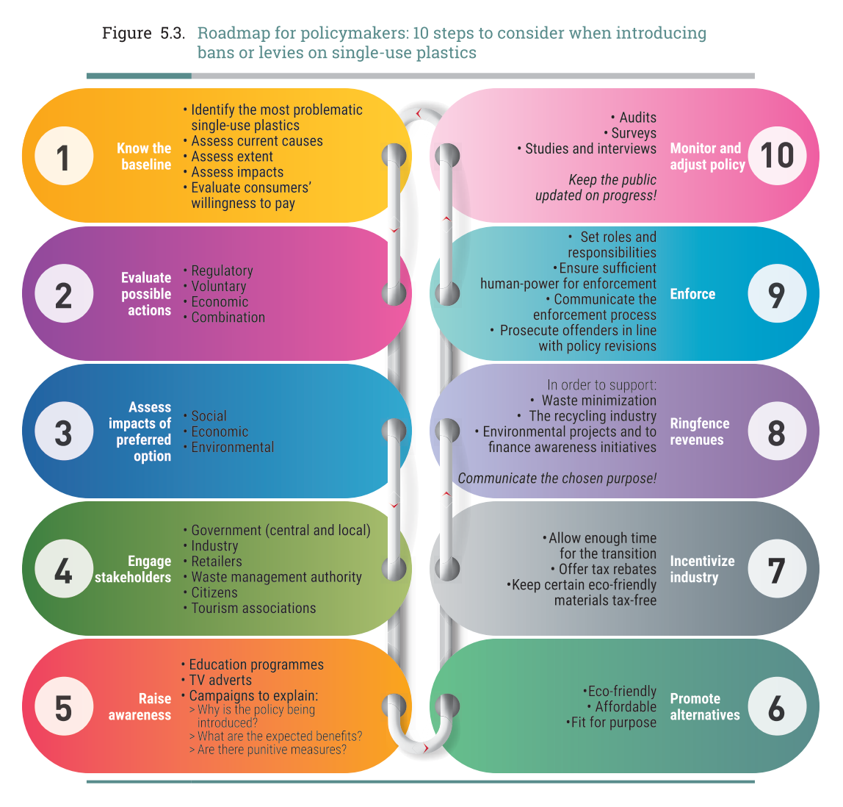

Appendix B
Table 1 - List of food businesses considered for the extrapolation of single-use plastics consumed by the food sector
Food business group | Businesses in group | Total number
AMS-owned businesses in the Nest | Blue Chip Cafe  Gallery Patio & Lounge  Grand Noodle Emporium  Honour Roll  IWANA Taco  Ph Tea  Pie R Squared  Porch  The Pit  AMS Conferences & Catering | 10
Non-AMS owned businesses in the Nest | Liquid Nutrition  Grocery Checkout  The Delly  The Soup Market | 4
UBC Food Services | Residence Dining:  - Open Kitchen  - Totem Dining Room  - Gather At Vanier  Residence Markets:  - Gage Market  - Harvest  - Hero Coffee + Market  - Hubbards Global Market  - Magda’s Late Night Market  Restaurants:  - The Point  - Sage Restaurant  - Ideas Lunch & Wine Bar  Café & Specialty:  - Daily Dose  - Ike’s Café  - IRC Snackbar  - Law Café  - The Loop Café  - Magma Café  - Mercante  - Neville’s Café  - Perugia Italian Caffè  - Sauder Exchange Café  - Stir It Up Café  Food Trucks:  - Hungry Nomad  - Dog House  - School Of Fish  Scholar’s Catering | 26
Franchises | Bento Sushi  Booster Juice (Life Bldg)  Pacific Poké  Triple O’s  Tim Hortons (David Lam Bldg)  Tim Hortons (Forest Sciences Bldg)  Starbucks (Bookstore)  Starbucks (Fred Kaiser Bldg)  Starbucks (Life Bldg)  Starbucks (Agronomy Rd)  Subway (Life Bldg) | 11
Other food locations | UBC Trolley bus loop:  - JJ Bean  - JamJar Canteen  - Nori Bento & Udon  - Tacomio UBC  - Uncle Fatih’s Pizza  - Bao Down  - The Boulevard Coffee Roasting Co.  - Majony & Sons Public House  Loafe Café  Great Dane Coffee  Café MOA  Koerner’s Pub  Bean Around the World Coffee House & Bistro  Corner Café | 16

Appendix C
Infographic material

